Design and Implementation of an Ultrasonic-Based Real-Time Fuel Level Monitoring System Integrated with Deep Sea Electronics
(DSE 7320 MKII) Controllers

Design and Implementation of an Ultrasonic-Based Real-Time Fuel Level Monitoring System Integrated with Deep Sea Electronics (DSE 7320 MKII) Controllers

Abstract
Accurate monitoring of fuel levels in generator day tanks is essential for ensuring operational efficiency, reducing fuel waste, and enabling predictive maintenance in industrial and telecommunication infrastructures. This study presents the design and implementation of a real-time fuel level monitoring system based on ultrasonic sensing, embedded processing, and analog interfacing. An AJ-SR04M ultrasonic sensor is utilized to measure the distance to the fuel surface, and an ESP32 microcontroller processes the acquired signal to determine fuel volume and percentage using predefined tank geometry. The processed digital data is converted into a calibrated analog voltage using an MCP4725 digital-to-analog converter, allowing seamless integration with the Deep-Sea Electronics (DSE 7320 MKII) controller. The controller interprets the voltage signal through a configured voltage-to-percentage mapping and displays real-time fuel levels. The system was deployed across six generator day tanks, demonstrating stable operation, accurate measurements, and compatibility with industrial control systems. The proposed solution offers a scalable and cost-effective approach to per-generator fuel monitoring in practical environments.

1. Introduction
Fuel management is a critical requirement in generator-based power systems, particularly in telecommunication infrastructures where uninterrupted operation must be maintained. Conventional fuel monitoring approaches are typically limited to bulk tank measurements or manual inspection methods, which lack the granularity required to assess individual generator performance. This limitation often leads to inefficient fuel usage, difficulty in identifying abnormal consumption patterns, and challenges in maintenance planning. With the advancement of embedded systems and Industrial Internet of Things (IIoT) technologies, there is an increasing demand for intelligent monitoring systems capable of delivering accurate, real-time data [6].
Ultrasonic sensing has emerged as a reliable and non-contact technique for liquid level measurement due to its low cost, robustness, and ease of integration [1], [5]. However, integration of such systems with industrial controllers presents a challenge, as most controllers accept analog signals rather than digital data streams. The Deep Sea Electronics (DSE 7320 MKII) controller, widely used in generator systems, relies on analog input channels for fuel level monitoring [4].
This study addresses this gap by developing a system that converts ultrasonic measurements into a calibrated analog voltage compatible with DSE controllers. The proposed system was implemented and deployed across six generator day tanks, demonstrating its effectiveness and scalability in real-world industrial environments.

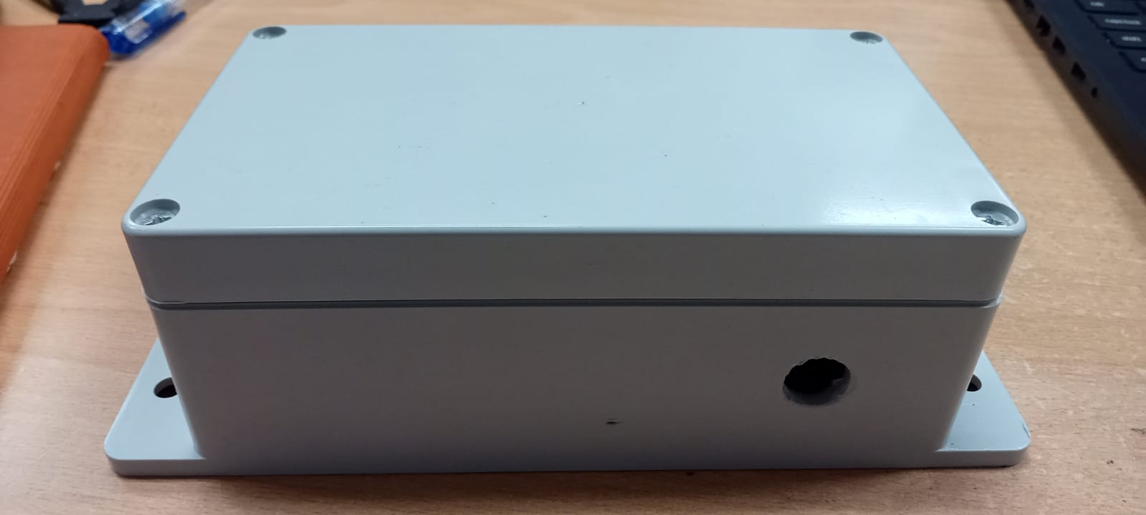
2. System Architecture
The proposed system consists of sensing, processing, and output integration subsystems that work together to provide real-time fuel monitoring. The sensing subsystem utilizes an AJ-SR04M ultrasonic sensor to measure the distance between the sensor and the fuel surface using the time-of-flight principle [5]. The processing subsystem is implemented using an ESP32 microcontroller, which offers high computational capability and integrated peripherals suitable for embedded applications [2].
The ESP32 processes the acquired signal by performing distance calculation, noise filtering, and conversion into fuel level parameters such as volume and percentage. The output subsystem uses an MCP4725 digital-to-analog converter to generate a continuous analog voltage proportional to the measured fuel level. The MCP4725 provides 12-bit resolution, ensuring sufficient precision for industrial applications [3].
This analog signal is then interfaced with the DSE 7320 MKII controller, which interprets the input through a configured voltage-to-percentage mapping. This architecture enables seamless integration of modern sensing technologies with legacy industrial systems without requiring major modifications.
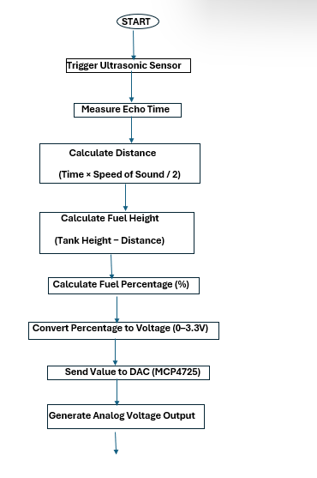
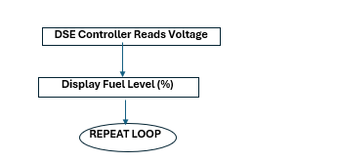

3. Methodology
The system operation is based on a sequence of measurement, computation, and conversion processes. The ultrasonic sensor measures the round-trip time of an acoustic pulse reflected from the fuel surface, allowing the distance to be calculated using the speed of sound in air [1]. The measured distance is then converted into fuel level based on predefined calibration parameters corresponding to the tank geometry.
The fuel percentage is calculated using a linear transformation between the minimum and maximum distance values, representing full and empty tank conditions. Similarly, fuel volume is estimated based on the geometric dimensions of the tank. The relationship between distance and fuel level is modeled as a linear function to simplify computation and ensure real-time performance.
To integrate with the DSE controller, the computed fuel level is mapped to a corresponding analog voltage within the range of 0 to 3.3 V. The MCP4725 DAC converts the digital value generated by the ESP32 into a smooth analog signal. The DSE 7320 MKII controller is configured with a voltage-to-percentage curve, allowing it to accurately interpret the analog signal as fuel level data [4].

Tank Measurements

* Ultrasonic sensor has blind area 1cm – 20/21 cm.
Because of that, in here we get full tank level as 20.3 cm from sensor.

Tank lid
Sensor
Tank
9.3 cm
0.5 cm
124.5 cm
Tank full level (actual)
Tank full level consider by us
4. System design

Pin diagram of the system

Ultrasonic Sensor - ESP32
ESP32 | Ultrasonic Sensor
GPIO18 | TRIG
GPIO19 | ECHO
5V | VCC
GND | GND

MCP4725 DAC - ESP32
ESP32 | MCP4725
GPIO21 | SDA
GPIO22 | SCL
3.3V | VCC
GND | GND

*** special notice
Do not place the LM2696 buck converter close to the AJ-SR04M.
Schematic diagram of the system

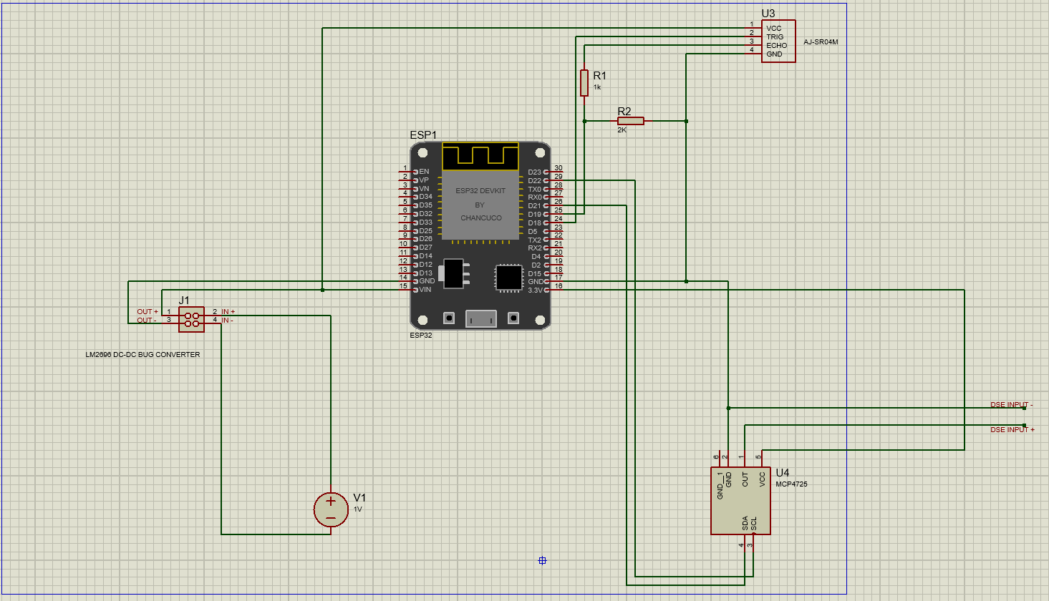
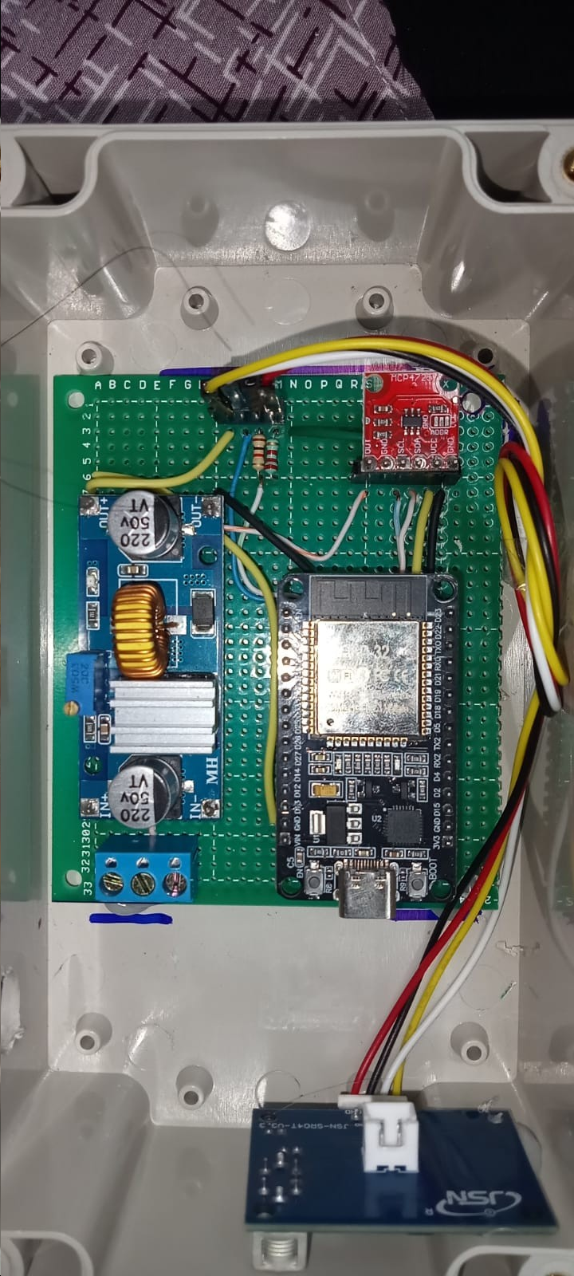

ESP32 code - https://github.com/thisara374/Ultrasonic-Fuel-Level-Monitoring-System-using-ESP32

Mapping of Voltages and Percentage

Percentage | Volatage
100% | 0V
80% | 0.66V
60% | 1.32V
40% | 1.98V
20% | 2.64V
0% | 3.30V

4. System Implementation
The system was implemented using a combination of hardware and software components designed for reliable real-time operation. The ESP32 microcontroller was programmed to generate trigger pulses and measure echo responses from the ultrasonic sensor using precise timing mechanisms. The measured values were processed using custom algorithms to calculate fuel level parameters.
The MCP4725 DAC was configured via the I2C interface to generate a stable analog voltage output corresponding to the calculated fuel level. An OLED display was incorporated for local visualization, providing real-time feedback of fuel level values. The TCA9548A I2C multiplexer was used to manage multiple I2C devices efficiently, ensuring reliable communication without address conflicts.
The hardware components were integrated into a compact system and installed on generator day tanks, with careful consideration given to environmental factors such as vibration and noise.

5. Results and Analysis
The developed fuel level monitoring system was experimentally evaluated across six generator day tanks under real operating conditions. The performance of the system was analyzed in terms of measurement accuracy, voltage linearity, response time, and stability of the analog output signal.
The ultrasonic sensor demonstrated reliable distance measurements within the calibrated operating range of 22 cm to 125 cm, corresponding to full and empty tank conditions, respectively. The measured distance values were converted into fuel percentage using a linear transformation model. The system achieved an effective resolution of approximately 0.97% per centimeter, which is derived from the usable sensing range of 103 cm. This resolution is sufficient for practical industrial fuel monitoring applications, where fine-grained measurement beyond 1% is typically not required.
The DAC output voltage exhibited a strong linear relationship with the measured fuel level. The mapping function implemented in the ESP32 ensured that the output voltage varied from 0 V at full tank condition (22 cm) to 3.3 V at empty condition (125 cm). The MCP4725 DAC, with its 12-bit resolution (4096 discrete levels), provided a theoretical voltage resolution of approximately 0.8 mV per step, allowing smooth and continuous analog signal generation. This high resolution ensured that the DSE 7320 MKII controller received a stable and noise-free analog signal for accurate interpretation.
The analog voltage output was directly interfaced with the DSE controller, where a custom voltage-to-percentage calibration curve was configured. Experimental observations showed that the fuel percentage displayed on the DSE controller closely matched the calculated values from the ESP32, with minimal deviation. The observed error was primarily attributed to minor fluctuations in ultrasonic readings and environmental factors rather than DAC or mapping inaccuracies.
The response time of the system, defined as the time between measurement acquisition and DAC output update, was observed to be less than one second. This performance enables near real-time monitoring of fuel levels, which is sufficient for generator applications where fuel level changes occur relatively slowly.
Long-term testing indicated that the system maintained stable operation without significant drift in measurements or voltage output. The use of constrained distance mapping and DAC value limiting ensured that the output remained within the valid operating range, preventing erroneous readings in extreme conditions such as sensor misalignment or overflow scenarios.

6. Discussion
The results confirm that the proposed system provides a reliable method for converting ultrasonic distance measurements into an industrially compatible analog signal. The integration of digital sensing with analog interfacing represents a key strength of this system, as it allows modern embedded technologies to be seamlessly integrated with legacy industrial controllers such as the DSE 7320 MKII.
One of the critical design considerations was ensuring the linearity and stability of the voltage output. The use of a 12-bit DAC significantly improves output smoothness compared to PWM-based approaches, which typically require additional filtering and may introduce ripple noise. By directly generating a true analog voltage, the system avoids signal distortion and ensures accurate interpretation by the DSE controller.
Another important aspect is the calibration process. The accuracy of the system depends heavily on correct mapping between distance and fuel level, as well as the voltage-to-percentage configuration in the DSE controller. Any mismatch in these mappings can lead to systematic errors. Therefore, proper calibration using known reference points (empty and full tank levels) is essential for achieving high accuracy.
Environmental factors such as fuel surface turbulence, foam formation, and temperature variations can introduce noise into ultrasonic measurements. These effects were observed to cause minor fluctuations in distance reading. However, the impact on overall system performance was limited due to the relatively slow rate of fuel level change in generator tanks. The implementation of averaging or filtering algorithms can further enhance measurement stability in future iterations.
The use of an I2C multiplexer also contributes to system reliability by isolating the DAC and display communication channels. This prevents interference between devices and ensures consistent DAC performance, which is critical for maintaining stable analog output.

7. Conclusion
This study presents a technically robust solution for real-time fuel level monitoring using ultrasonic sensing and analog signal interfacing. The system successfully converts distance measurements into a calibrated voltage signal compatible with the DSE 7320 MKII controller, enabling direct integration with existing generator control systems.
The experimental evaluation across six deployed units demonstrates that the system achieves high measurement accuracy, stable analog output, and reliable real-time performance. The use of a high-resolution DAC ensures precise voltage generation, while the ESP32 provides efficient processing and flexibility for system expansion.
Overall, the proposed system offers a scalable, cost-effective, and industry-compatible solution for fuel monitoring applications. Its ability to bridge digital sensing technologies with traditional analog control systems makes it particularly valuable for retrofitting existing infrastructure without requiring major modifications.

8. References
[1] J. Fraden, Handbook of Modern Sensors, 5th ed. New York, NY, USA: Springer, 2016.
[2] Espressif Systems, “ESP32 Technical Reference Manual,” 2022.
[3] Microchip Technology, “MCP4725 12-Bit DAC Datasheet,” 2020.
[4] Deep Sea Electronics, “DSE 7320 MKII Operator Manual,” 2021.
[5] A. Ibrahim et al., “Ultrasonic sensor-based liquid level measurement system,” IEEE Sensors Journal, vol. 19, no. 12, pp. 4575–4582, 2019.
[6] M. R. Palattella et al., “Internet of Things in the 5G era,” IEEE Communications Magazine, vol. 54, no. 12, pp. 32–39, 2016.

